2018 PEW RESEARCH CENTER’S AMERICAN TRENDS PANEL
WAVE 34 April 2018
April 23 – May 6, 2018

Base: ASK ALL
SCI1 [S]
Overall, do you think science has made life easier or more difficult for most people?

1 Easier
2 More difficult

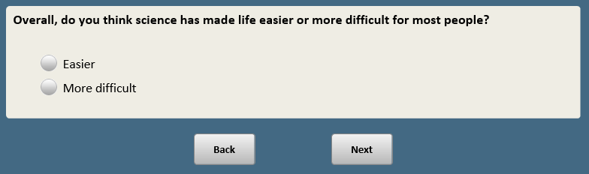

BASE: ASK ALL
Scripter: Randomize and record order of items a-c
SCI2 [S]
Do you think science has had a mostly positive or mostly negative effect on the quality of the following in the U.S.?

a. Food

1 Mostly positive
2 Mostly negative

b. Health care

1 Mostly positive
2 Mostly negative

c. The environment

1 Mostly positive
2 Mostly negative
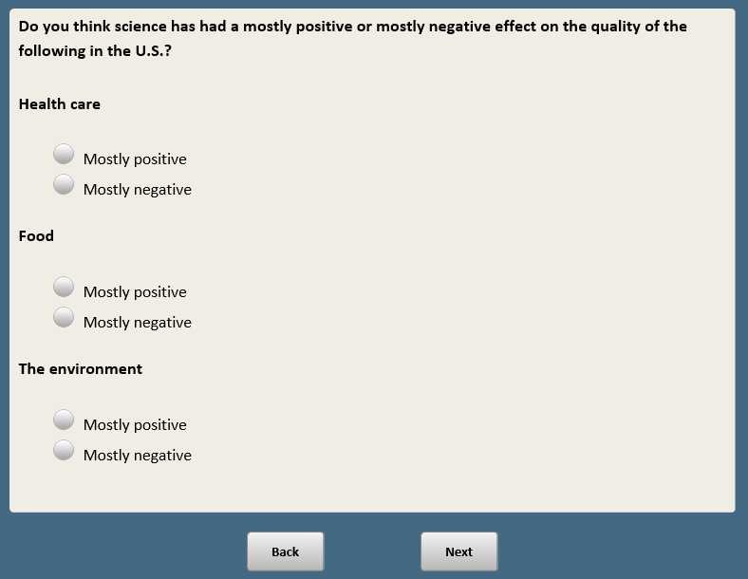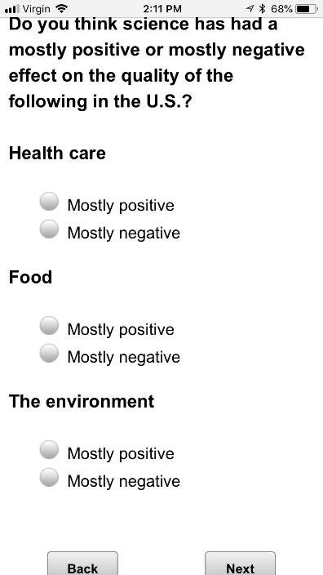

BASE: ASK ALL
Scripter: Randomize and record order of items a-c
SCI3 [S]
In your opinion, do you think government investments in the following usually pay off in the long run, or are they not worth it?

a. Basic scientific research

1 Government investments usually pay off in the long run
2 Government investments aren’t worth it

b. Engineering and technology

1 Government investments usually pay off in the long run
2 Government investments aren’t worth it

c. [ASK IF XFORM=2] Medical research {new}

1 Government investments usually pay off in the long run
2 Government investments aren’t worth it

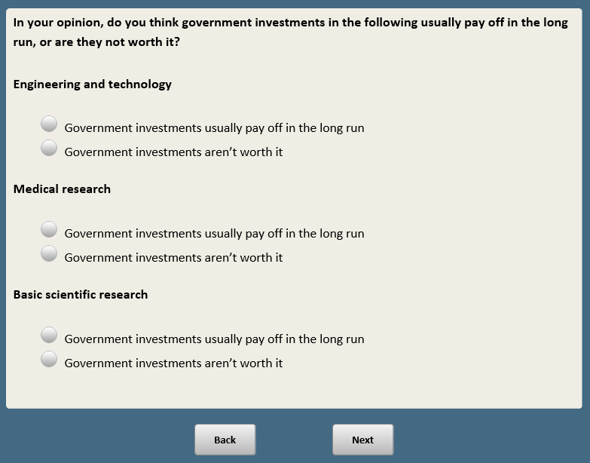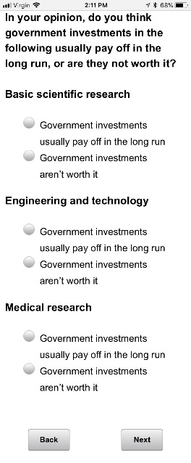

BASE: ASK ALL
Scripter: Randomize and record response order
SCI4 [S]
Which statement comes closer to your view, even if neither is exactly right?

1 Government investment in research is ESSENTIAL for scientific progress
2 Private investment will ensure that enough scientific progress is made, even without government investment

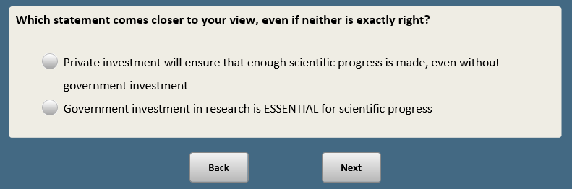

BASE: ASK ALL
SCI5 [S]
On another topic…

All in all, do you favor or oppose the use of animals in scientific research?

- Favor
- Oppose

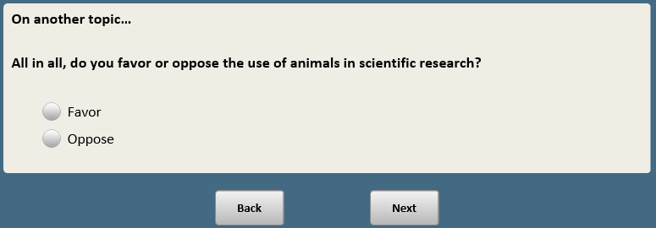

BASE: ASK ALL
Scripter: Randomize and record order of EAT1-EAT2. Show on same screen.
EAT1 [S]
[Show before first question: Thinking about yourself…]

How often do you choose foods to eat because they are healthy and nutritious?

- All of the time
- More than half of the time
- About half of the time
- Less than half of the time
- Never

BASE: ASK ALL
Scripter: Randomize and record order of EAT1-EAT2. Show on same screen.
EAT2 [S]
How often do you choose foods to eat because they are easy and most convenient?

- All of the time
- More than half of the time
- About half of the time
- Less than half of the time
- Never

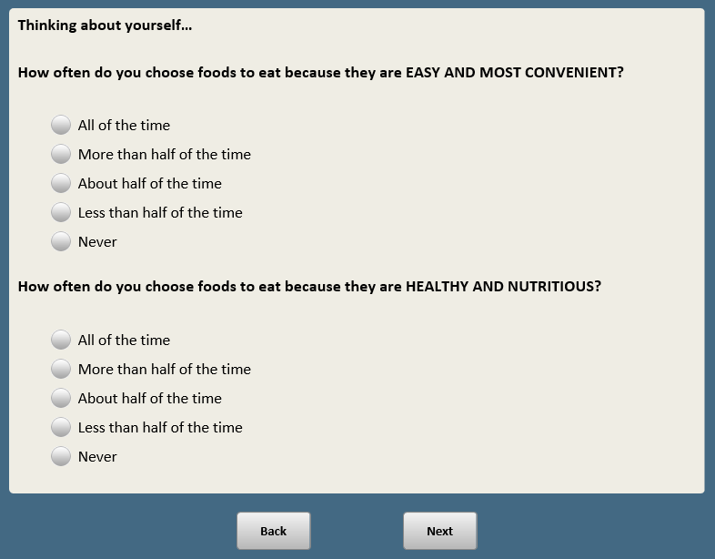

BASE: ASK ALL
Scripter: Unselect items a-c if item d is selected.
FUD30 [M]
Do you currently have any kind of food intolerance or food allergy?
[Check all that apply]

a. I have a severe allergic reaction to some foods
b. I have a mild or moderate allergic reaction to some foods
c. I have an intolerance to some foods
[SPACE]
d. No, none of these [S]

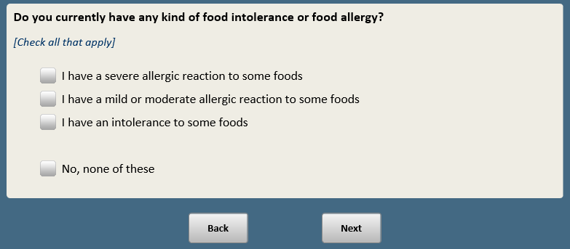

BASE: ASK ALL
Scripter: Randomize and record order of items a-j. Always keep k last.
EAT3 [M]
Which of the following, if any, do you restrict or limit eating on a regular basis?
[Check all that apply]

- Fat
- Meat
- Dairy
- Salt
- Cholesterol
- Sugar
- Artificial preservatives
- Artificial colors
- Artificial sweeteners
- Gluten
[SPACE]
- None of these [S] [ANCHOR]

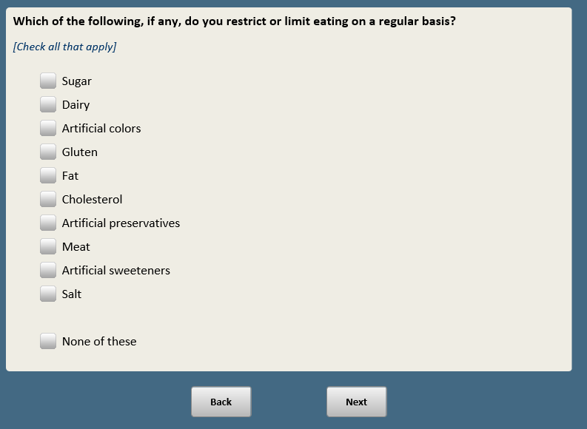

BASE: ASK ALL
Show FUD22 and FUD24 on the same screen
FUD22 [S]
How much of the food you eat is organic?

1 Most of it
2 Some of it
3 Not too much
4 None at all

Note: NO FUD23

BASE: ASK ALL
Show FUD22 and FUD24 on the same screen
FUD24 [S]
Do you think organic fruits and vegetables are generally…

1 Better for one’s health than conventionally grown foods
2 Worse for one’s health than conventionally grown foods
3 Neither better nor worse for one’s health than conventionally grown foods
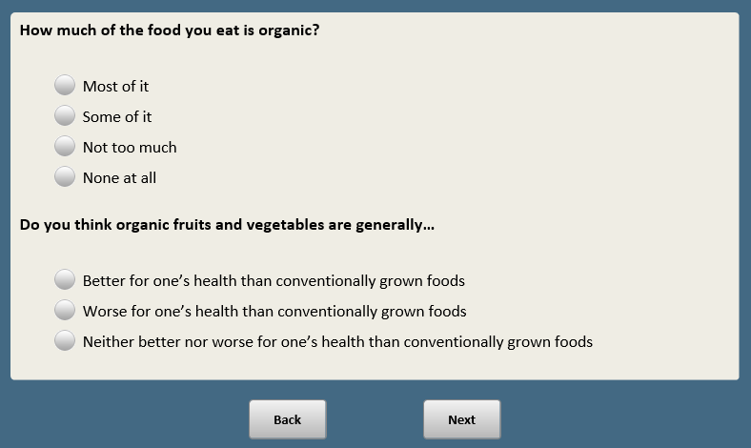

NOTE: NO EAT4

BASE: ASK ALL
Scripter: Randomize and record order of a-d
EAT5 [S]
How much health risk, if any, does eating each of the following have for the average person over the course of their lifetime?

- Fruits and vegetables grown with pesticides

1 A great deal of health risk
2 Some health risk
3 Not too much health risk
4 No health risk at all

- Meat from animals that have been given antibiotics or hormones

1 A great deal of health risk
2 Some health risk
3 Not too much health risk
4 No health risk at all

- Food and drinks with artificial coloring

1 A great deal of health risk
2 Some health risk
3 Not too much health risk
4 No health risk at all

- Food and drinks with artificial preservatives

1 A great deal of health risk
2 Some health risk
3 Not too much health risk
4 No health risk at all
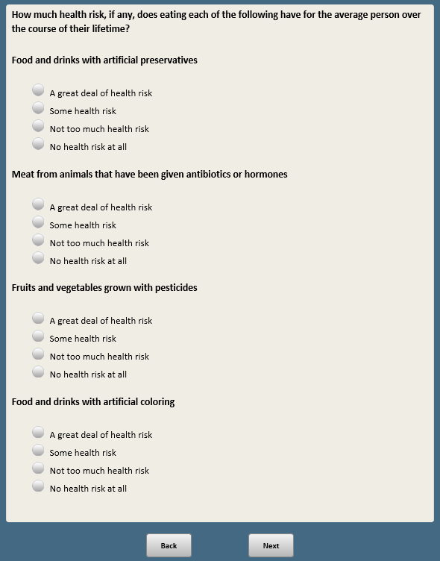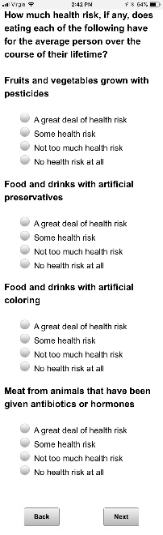

BASE: ASK ALL
Scripter: Randomize and record response order
EAT6 [S]
Which of these statements comes closer to your view, even if neither is exactly right?

- The average person is exposed to additives in the food they eat every day, which pose a serious risk to their health
- The average person is exposed to additives in the food they eat every day but they eat such a small amount that this does not pose a serious health risk

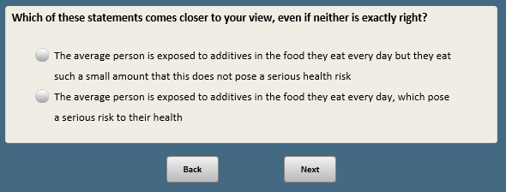

BASE: ASK ALL
Scripter: Show FUD32 and FUD33A on the same screen
FUD32 [S]
Genetically modified foods, sometimes called GMOs, come from a technique that adds genes from other organisms to change that food’s genetic characteristics.

How much, if anything, have you heard or read about foods with genetically modified ingredients?

1 A lot
2 A little
3 Nothing at all

BASE: ASK ALL
Scripter: Show FUD32 and FUD33A on the same screen
FUD33A [S]
Do you think foods with genetically modified ingredients are generally…

1 Better for your health than foods with no genetically modified ingredients
2 Worse for your health than foods with no genetically modified ingredients
3 Neither better nor worse for your health than foods with no genetically modified ingredients
[SPACE]
8 Not sure

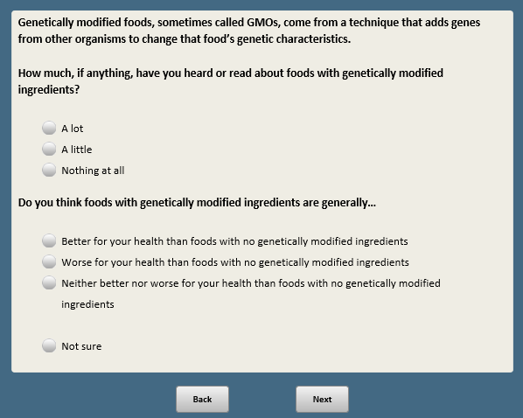

Base: FUD33A=8 or 99 (ASK IF NO ANSWER OR NOT SURE)
FUD33B [S]
Even if you are not sure, which is closer to your views? Do you think foods with genetically modified ingredients are generally…

1 Better for your health than foods with no genetically modified ingredients
2 Worse for your health than foods with no genetically modified ingredients
3 Neither better nor worse for your health than foods with no genetically modified ingredients

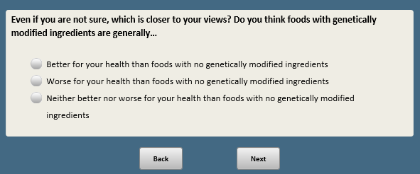

NOTE: NO FUD34

BASE: ASK ALL
FUD35 [S]
How much do you, personally, care about the issue of genetically modified foods?

1 A great deal
2 Some
3 Not too much
4 Not at all

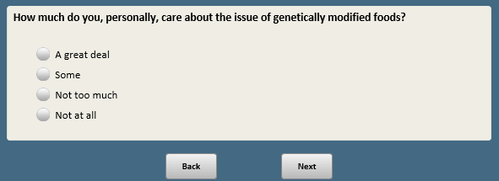

NOTE: NO FUD36

BASE: ASK ALL
Scripter: Randomize and record order of items a-d
FUD37 [S]
How likely is it that genetically modified foods will…

a. Lead to more affordably-priced food

1 Very likely
2 Fairly likely
3 Not too likely
4 Not at all likely

b. Lead to health problems for the population as a whole

1 Very likely
2 Fairly likely
3 Not too likely
4 Not at all likely

c. Create problems for the environment

1 Very likely
2 Fairly likely
3 Not too likely
4 Not at all likely

d. Increase the global food supply

1 Very likely
2 Fairly likely
3 Not too likely
4 Not at all likely
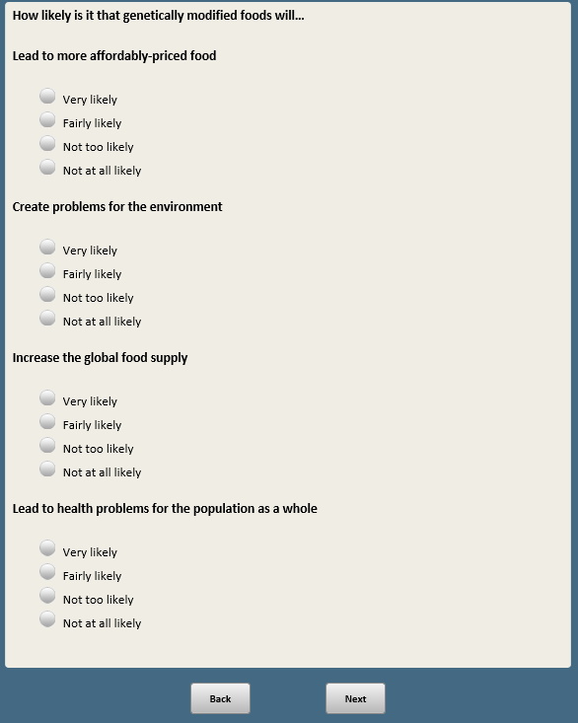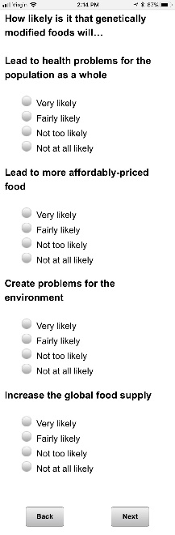

BASE: ASK ALL
MED1 [S]
Thinking now about medicine…

Which of these statements comes closer to your point of view, even if neither is exactly right?

- Medical treatments these days are worth the costs because they allow people to live longer and better quality lives
- Medical treatments these days often create as many problems as they solve

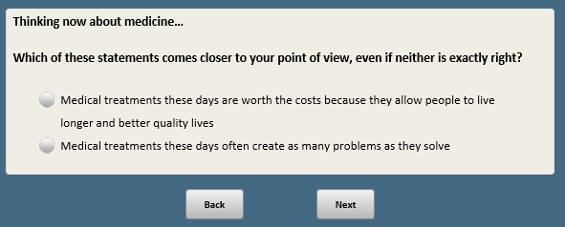
_____________________________________________________________________________

BASE: ASK ALL
Scripter: Randomize and record order of items a-g
Scripter: Split onto two screens
MED2 [S]
Thinking about medical treatments these days, how much of a problem, if at all, are each of the following?

- Healthcare providers are too quick to order tests and procedures that may not be necessary

- A big problem
- A small problem
- Not a problem

- People rely too much on prescription medicines that may not be necessary

- A big problem
- A small problem
- Not a problem

- New treatments are made available before we fully understand how they affect people’s health

- A big problem
- A small problem
- Not a problem

- The cost of treatments makes quality medical care unaffordable

- A big problem
- A small problem
- Not a problem

- New treatments are so complex that patients cannot make informed decisions

- A big problem
- A small problem
- Not a problem

- Side effects from prescription medicines create as many problems as the medicines solve

- A big problem
- A small problem
- Not a problem

- The process for evaluating the safety and effectiveness of new medical treatments is too slow

- A big problem
- A small problem
- Not a problem

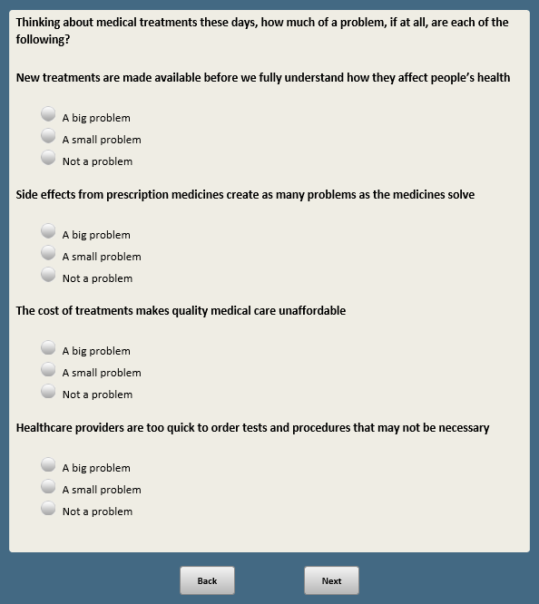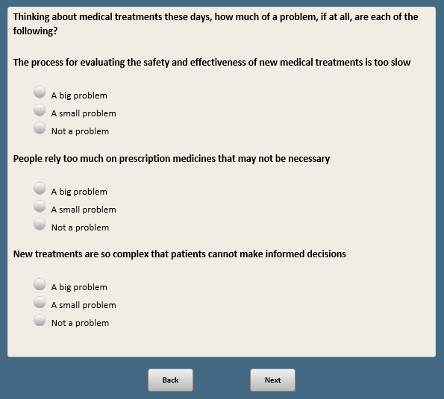
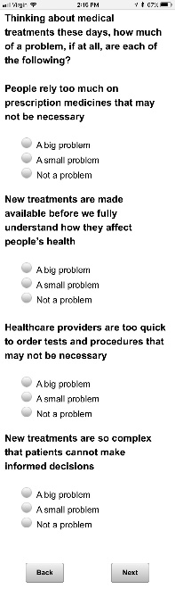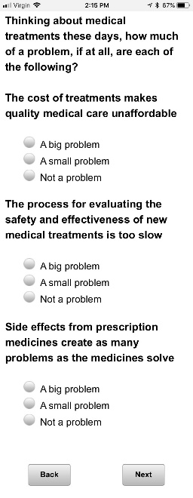
_____________________________________________________________________________

BASE: ASK ALL
MED3 [S]
How much, if anything, have you heard or read about gene editing that can be used to change a baby’s genetic characteristics?

- A lot
- A little
- Nothing at all

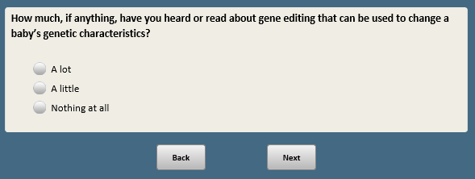

BASE: ASK ALL
Scripter: Randomize and record order of items a-c
MED4 [S]
Do you think each of the following is an appropriate use of medical technology or is it taking medical technology too far?

- Changing a baby's genetic characteristics to make the baby more intelligent

1 An appropriate use of medical technology
2 Taking medical technology too far

- Changing a baby's genetic characteristics to TREAT a serious disease or condition the baby would have at birth

1 An appropriate use of medical technology
2 Taking medical technology too far

- Changing a baby's genetic characteristics to REDUCE THE RISK of a serious disease or condition that could occur over the course of his or her lifetime

1 An appropriate use of medical technology
2 Taking medical technology too far

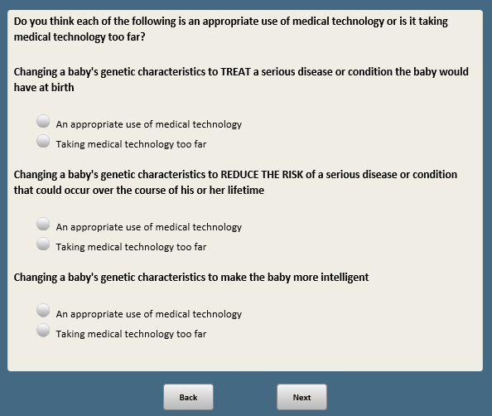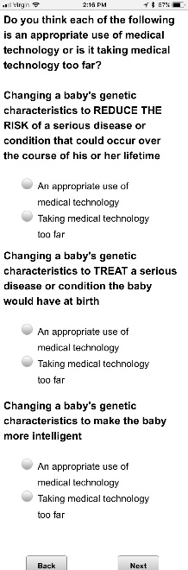

BASE: ASK ALL
MED5 [S]
Thinking about what you have heard or read, how well do you think medical researchers understand the health risks and benefits of changing a baby’s genetic characteristics?

1 Very well
2 Fairly well
3 Not too well
4 Not at all well

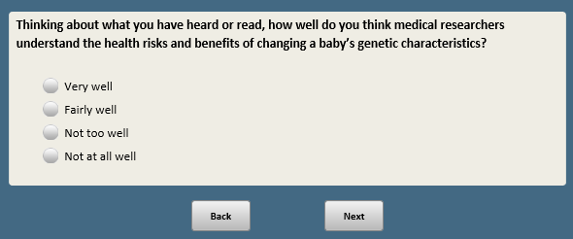

BASE: ASK ALL
Scripter: Randomize and record order of items a-e
MED6 [S]
Thinking about society as a whole…

How likely, if at all, do you think each of the following would be to occur if gene editing to change a baby’s genetic characteristics becomes widely available?

a. Even if gene editing is used appropriately in some cases, others will use these techniques in ways that are morally unacceptable

1 Very likely
2 Fairly likely
3 Not too likely
4 Not at all likely

b. These techniques will help people live longer and better quality lives

1 Very likely
2 Fairly likely
3 Not too likely
4 Not at all likely

c. We will use these techniques before we fully understand how they affect people’s health

1 Very likely
2 Fairly likely
3 Not too likely
4 Not at all likely

d. Inequality will increase because this option will be available only for the wealthy

1 Very likely
2 Fairly likely
3 Not too likely
4 Not at all likely

e. Development of these techniques will pave the way for new medical advances that benefit society as a whole

1 Very likely
2 Fairly likely
3 Not too likely
4 Not at all likely
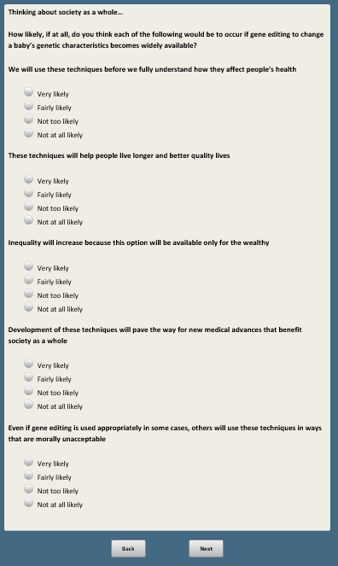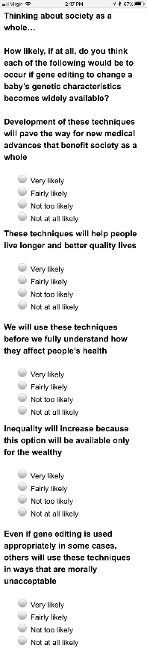

BASE: ASK ALL
MED7 [S]
If gene editing to change a baby’s genetic characteristics required testing on human embryos in order to develop these techniques, do you think this would be…

1 An appropriate use of medical technology
2 Taking medical technology too far

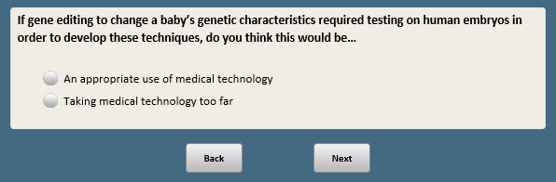

Scripter: Randomize and record order of BIOTECHA-BIOTECHE

BASE: ASK ALL
BIOTECHA [S]
[SHOW ON SAME SCREEN FOR FIRST BIOTECH ITEM ONLY:Genetic engineering can be used to change the genetic characteristics of animals. Thinking about the following applications of genetic engineering…]

Do you think genetic engineering of animals to increase their production of specific proteins that will lead to more nutritious meat would be…

- An appropriate use of technology
- Taking technology too far
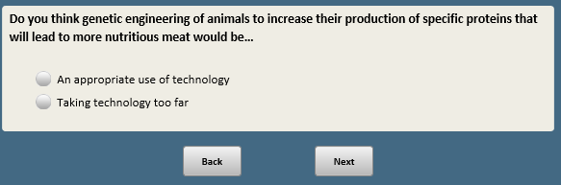

BASE: ASK ALL
BIOTECHB [S]
Do you think bringing back an animal that is currently extinct by genetically engineering a closely-related species would be…

- An appropriate use of technology
- Taking technology too far

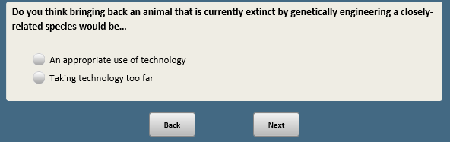

BASE: ASK ALL
BIOTECHC [S]
Do you think genetic engineering of mosquitoes that would prevent them from reproducing in order to prevent the spread of some mosquito-borne diseases would be…

- An appropriate use of technology
- Taking technology too far
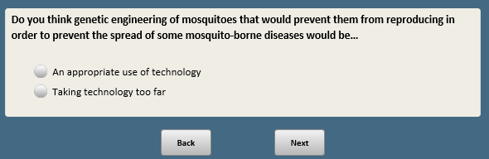

BASE: ASK ALL
BIOTECHD [S]
Do you think genetic engineering of animals to grow organs or tissues that can be used for humans needing a transplant would be…

1 An appropriate use of technology
2 Taking technology too far
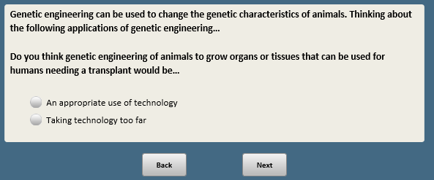

BASE: ASK ALL
BIOTECHE [S]
Do you think genetic engineering of aquarium fish to change their appearance, causing them to glow would be…

- An appropriate use of technology
- Taking technology too far

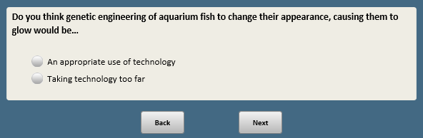

CREATE NOBIOTECH_FILL [S]
If only one selection of BIOTECHA-BIOTECHE=2, NOBIOTECH_FILL=the item selected as 2. If multiple selections of BIOTECHA-BIOTECHE=2, randomly assign NOBIOTECH_FILL one of the selections.

IF BIOTECHA=2 NOBIOTECH_FILL=1 (genetic engineering of animals to increase their production of specific proteins that will lead to more nutritious meat)
IF BIOTECHB=2 NOBIOTECH_FILL=2 (bringing back an animal that is currently extinct by genetically engineering a closely-related species)
IF BIOTECHC=2 NOBIOTECH_FILL=3 (genetic engineering of mosquitoes that would prevent them from reproducing in order to prevent the spread of some mosquito-borne diseases)
IF BIOTECHD=2 NOBIOTECH_FILL=4 (genetic engineering of animals to grow organs or tissues that can be used for humans needing a transplant)
IF BIOTECHE=2 NOBIOTECH_FILL=5 (genetic engineering of aquarium fish to change their appearance, causing them to glow)

BASE: IF BIOTECHA=2 or BIOTECHB=2 or BIOTECHC=2 OR BIOTECHD=2 OR BIOTECHE=2
Scripter: FILL TOPIC FROM QUESTION STEM WHERE BIOTECH=2. IF MORE THAN ONE BIOTECHA-BIOTECHE=2, RANDOMLY SELECT ONE ITEM TO FILL TOPIC AND RECORD ITEM SHOWN
NOBIOTECH [O]
What is the MAIN REASON you think that [NOBIOTECH_FILL] would be taking technology too far?
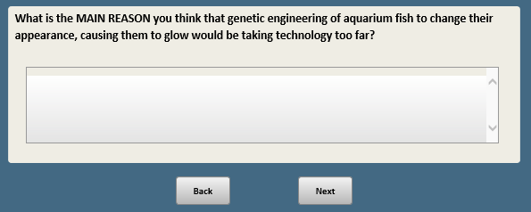

Base: IF XFORM=1
Scripter: Randomize and record order of responses 1 and 2
EVOONE [S]
Thinking about the development of human life on Earth…

Which statement comes closer to your own views, even if neither is exactly right?

- Humans have evolved over time
- Humans have existed in their present form since the beginning of time

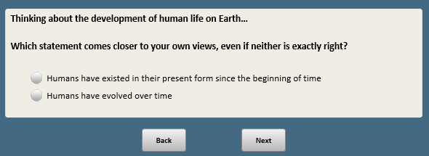

Base: EVOONE= 99 (ASK IF NO ANSWER ON EVOONE)
Scripter: Show in same order as EVOONE
Scripter: Add custom prompt if 3 (Other view) selected and no text is included in the box: You did not provide a response in the text box. If you would like to skip, click Next.
EVOTWO [S]
Even if you are not sure, which of these is closer to your views?

- Humans have evolved over time
- Humans have existed in their present form since the beginning of time
[SPACE]
- Other view [O]

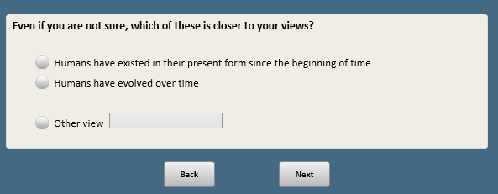

Base: EVOONE=1 or EVOTWO=1
Scripter: Randomize and record response order
EVOTHREE [S]
Which of these statements comes closer to your own views, even if neither is exactly right?

1 Humans have evolved over time due to processes such as natural selection; God or a higher power had no role in this process
2 Humans have evolved over time due to processes that were guided or allowed by God or a higher power

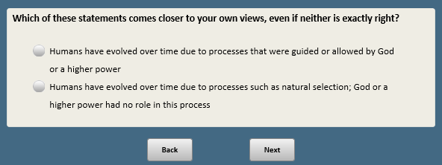

Base: XFORM=2
Scripter: Randomize and record order of responses 1 and 3. Always keep 2 in the middle.
EVOPERS3 [S]
Thinking about the development of human life on Earth…

Which statement comes closest to your view?

- Humans have evolved over time due to processes such as natural selection; God or a higher power had no role in this process
- Humans have evolved over time due to processes that were guided or allowed by God or a higher power [KEEP IN MIDDLE]
3 Humans have existed in their present form since the beginning of time
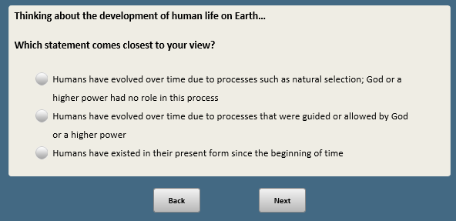

Base: EVOPERS3=99 (ASK IF NO ANSWER ON EVOPERS3)
Scripter: Show in same order as EVOPERS3
Scripter: Add custom prompt if 4 (Other view) selected and no text is included in the box: You did not provide a response in the text box. If you would like to skip, click Next.
EVOPERS3A [S]
Even if you are not sure, which statement comes closest to your view?

- Humans have evolved over time due to processes such as natural selection; God or a higher power had no role in this process
- Humans have evolved over time due to processes that were guided or allowed by God or a higher power
3 Humans have existed in their present form since the beginning of time
[SPACE]
4 Other view [O]

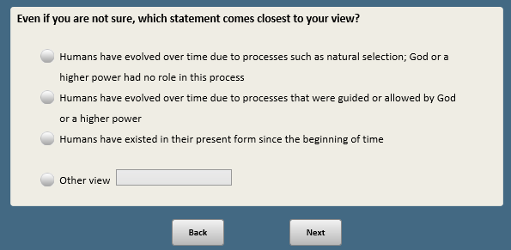

BASE: ASK ALL
Scripter: Show in same order as EVOONE or EVOPERS3
EVOBIOA [S]
From what you have heard or read, which of these statements about the development of human life on Earth comes closest to WHAT MOST BIOLOGICAL SCIENTISTS SAY?

- Humans have evolved over time due to processes such as natural selection
- Humans have existed in their present form since the beginning of time
[SPACE]
- Not sure [ANCHOR]
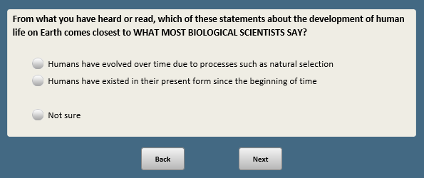

Base: EVOBIOA=8 or 99 (ASK IF EVOBIOA=NOT SURE OR NO ANSWER)
Scripter: Show in same order as EVOBIOA
EVOBIOB [S]
Even if you are not sure, from what you have heard or read, which of these statements about the development of human life on Earth comes closest to WHAT MOST BIOLOGICAL SCIENTISTS SAY?

1 Humans have evolved over time due to processes such as natural selection
2 Humans have existed in their present form since the beginning of time

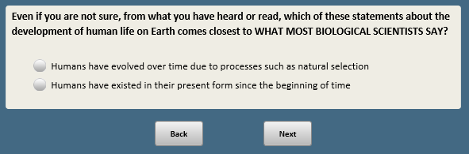

BASE: ASK ALL
BIO15 [S]
Have you seen a health care provider FOR AN ILLNESS OR MEDICAL CONDITION in the past 12 months, or not?

1 Yes
2 No

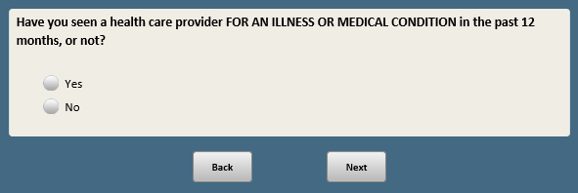

BASE: ASK ALL
Scripter: Show G1 and G2 on same screen
G1 [S]
Do you, or does anyone in your immediate family, have a gene that predisposes you to a serious disease such as Alzheimer’s, cancer, heart disease or sickle cell anemia?

- Yes
- No
- Not sure

BASE: ASK ALL
G2 [S]
Have you, or has anyone in your immediate family, ever had a genetic test, or haven’t you done this?

- Yes
- No
- Not sure

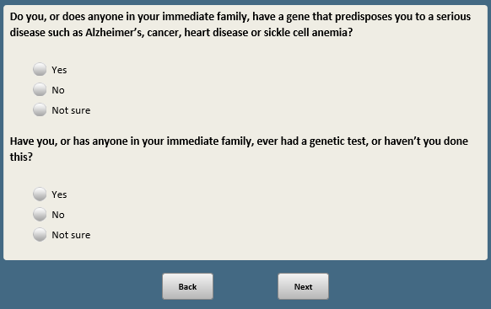

Base: F_RESPONDED_W17>1
Scripter: Randomize and record order of responses 1 and 2. Anchor 8 last.
KNOSCT22 [S]
Here’s a different kind of question. (If you don’t know the answer, select “Not sure.”) As far as you know...

Which is the better way to determine whether a new drug is effective in treating a disease? If a scientist has a group of 1,000 volunteers with the disease to study, should she…

1 Give the drug to all of them and see how many get better
2 Give the drug to half of them but not to the other half, and compare how many in each group get better
[SPACE]
8 Not sure [ANCHOR]
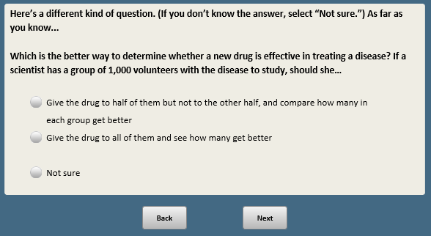

Scripter: RANDOMIZE AND RECORD ORDER OF KNOSCT23-KNOSCT34

Base: F_RESPONDED_W17>1
Scripter: Randomize and record order of responses 1-4. Anchor 8 last.
KNOSCT23 [S]
Which gas is made as a consequence of burning fossil fuels? Is it…

1 Carbon dioxide
2 Hydrogen
3 Helium
4 Radon
[SPACE]
8 Not sure

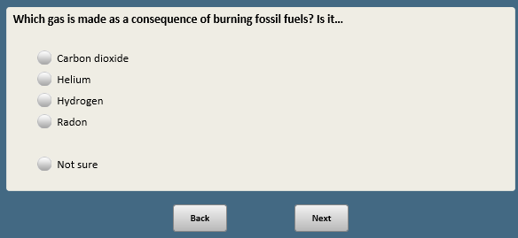

NOTE: NO QUESTIONS KNOSCT24 AND KNOSCT25 AND KNOSCT26

Base: F_RESPONDED_W17>1
Scripter: Only allow number 0-300. If respondent enters something other than numbers, prompt “Please enter just a number with no characters like a decimal or % sign.”
Scripter: If both Not Sure and number entered, prompt “You selected “Not sure” and gave a percentage. Please update your response to one or the other.”
Scripter: If respondent enters a number larger than 300, prompt “You entered a number that is too large. Please enter a smaller number or check “Not sure”.”
KNOSCT27 [Q, range 0-300. Include checkbox]
If the chances that an old bridge will collapse starts at 1% in week 1 and doubles each week (as shown below), what is the chance that the old bridge will collapse during week 7?

Chances the bridge will collapse is…
1% at Week 1
2% at Week 2
4% at Week 3
8% at Week 4

Enter the % chance that the bridge will collapse at Week 7 (if the bridge is still standing after Week 6)

[Q, range 0-300] % at Week 7
[SPACE]
888 Not sure [S]

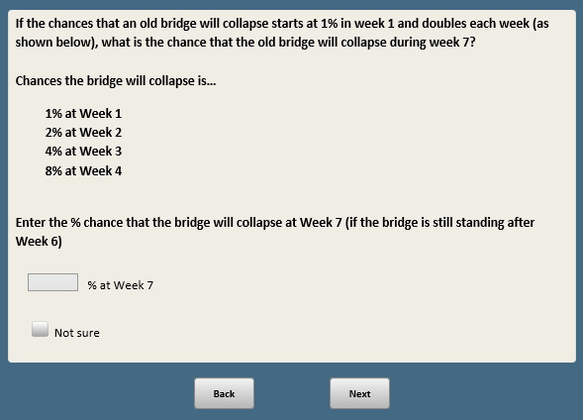

Base: F_RESPONDED_W17>1
Scripter: Randomize and record order of items a-d. Anchor e and f.
KNOSCT28 [M]
Which of the following conditions can be treated effectively by antibiotic medications?
[Check all that apply]

a. Viral infections (such as a cold)
b. Fungal infections (such as athlete’s foot)
c. Bacterial infections (such as strep throat infections)
d. Allergic reactions to insect bites
e. None of these [S] [ANCHOR]
[SPACE]
f. Not sure [S] [ANCHOR]

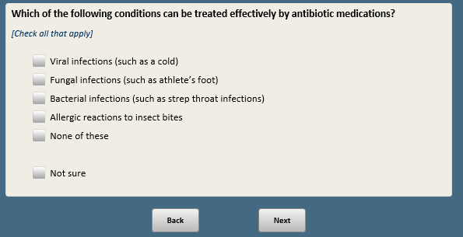

Base: F_RESPONDED_W17>1
Scripter: Randomize and record order of responses 1-3. Anchor 8.
KNOSCT29 [S]
If a scientist wants to determine if a new drug is effective at treating high blood pressure by giving half of a group of 1,000 volunteers a new medication and the other half a “sugar pill” she wants to rule out…

1 A placebo effect
2 A third person effect
3 A false consensus effect
[SPACE]
8 Not sure

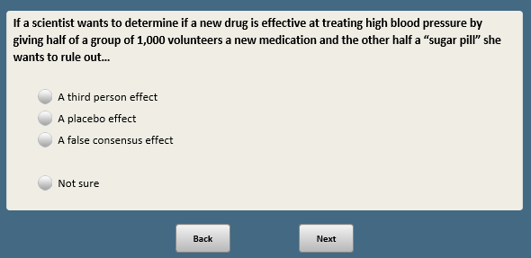

NOTE: NO QUESTION KNOSCT30

Base: F_RESPONDED_W17>1
Scripter: Randomize and record order of responses 1-3. Anchor 8.
KNOSCT31 [S]
Which of these terms refers to health benefits occurring when most people in a population get a vaccine?

1 Herd immunity
2 Population control
3 Vaccination rate
[SPACE]
8 Not sure [anchor]

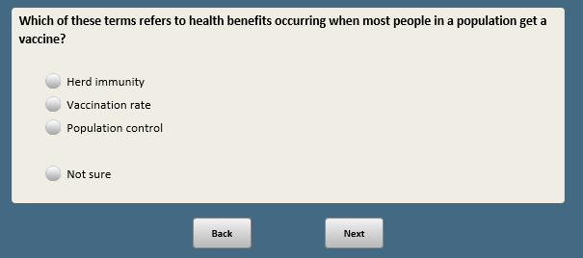

Base: F_RESPONDED_W17>1
Scripter: Randomize and record items a-d. Anchor e and f last.
KNOSCT32 [M]
Which of the following can be genetically modified?
[Check all that apply]

- An apple
- Salmon
- A mosquito
- Corn
- None of these [S] [ANCHOR]
[SPACE]
f. Not sure [S] [ANCHOR]

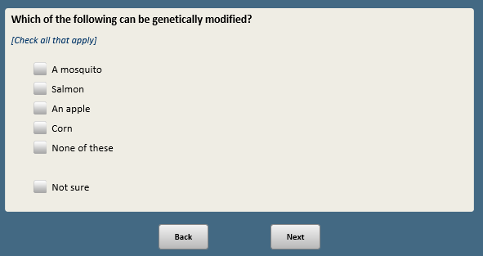

Base: F_RESPONDED_W17>1
Scripter: Randomize and record response order. Show in order 1-3 or 3-1 only. Anchor 8.
KNOSCT33 [S]
Humans and mice share the same genetic make-up by…

1 Less than 10%
2 Between 11% and 49%
3 About 50% or more
[SPACE]
8 Not sure [ANCHOR]

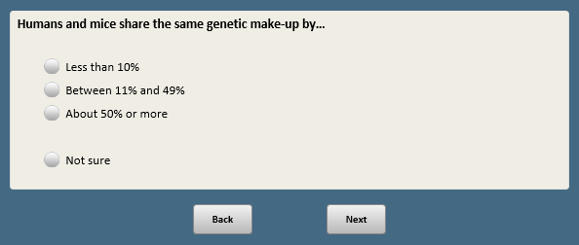

Base: F_RESPONDED_W17>1
Scripter: Randomize and record order of responses 1-4. Anchor 8.
KNOSCT34 [S]
Which gas makes up most of the Earth's atmosphere?

1 Hydrogen
2 Nitrogen
3 Carbon dioxide
4 Oxygen
[SPACE]
8 Not sure [ANCHOR]

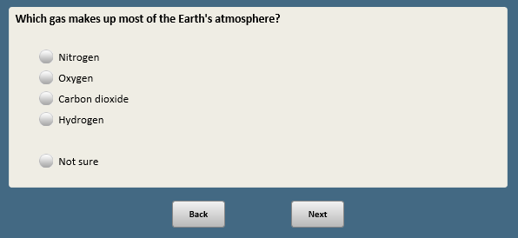

Open-end responses are excluded from public datasets to protect the confidentiality of ATP panelists

